.while designing/programming keep in mind the main goal:

***Promotional game that makes people interested in programming // following a Computer Science education.***

aspects relating to the goal:

>showcase programming abillities

>create out of nothing

TODO:

**Level Aspect:**

* Derive a theme
  + factory > …. > end level
  + color coding for interactabale objects
  + good distinction back and foreground
* explain game mechanics

Level Selection!:

puzzle solvable in 2 ways, both leadng to other next area. || signpost assisting meaning

Themes:

Sci-Fi → neon lights, flashy. metallic, robotic, industrial outside of main city

level structure:

Dity, industrial Factory (escape > find signpost to main city) [noon]

noisy freeway (on your way to main city > signpost) [afternoon]

Outside of centre in the city -> homes, appartments, neon lights, outskirts of city [dusk]

Centre of city -> malls, shops, people/robots walking around, crowded, [nighttime]

shopping mall > inside overcovered area of the city, shops and food and stuff. Crowded

City park > nice, clean, not crowded - dawn of new day

park robot catcher > try to escape > gets you > drags you back to factory (??)

**Sound Aspect:**

* sound for backgrounds per theme
  + factory > sci-fi outside > end level
* Sound FX for:
  + interacting with an object (selection/deselection)
  + Jumping/Landng on certain objects (floor types)
  + Sound FX for typing in terminal
    - per typestroke
    - space is special (?)
    - Enter -> error sound (screen shake)
    - Enter -> success sound
  + Background noise (extra sounds above the background sound)

**Gameplay Aspect:**

* list of possible interactions
* Jump, walk, (run)
* enemies / avoidable terrain

**Story Aspect:**

* contextualize setting / actions..

(where is the robot going? why? How is it that he can manipuluate some objects but not others?)

>> not nessesairly has to be explained but might be nice to have some context.

Brainstorm Session

- Level:

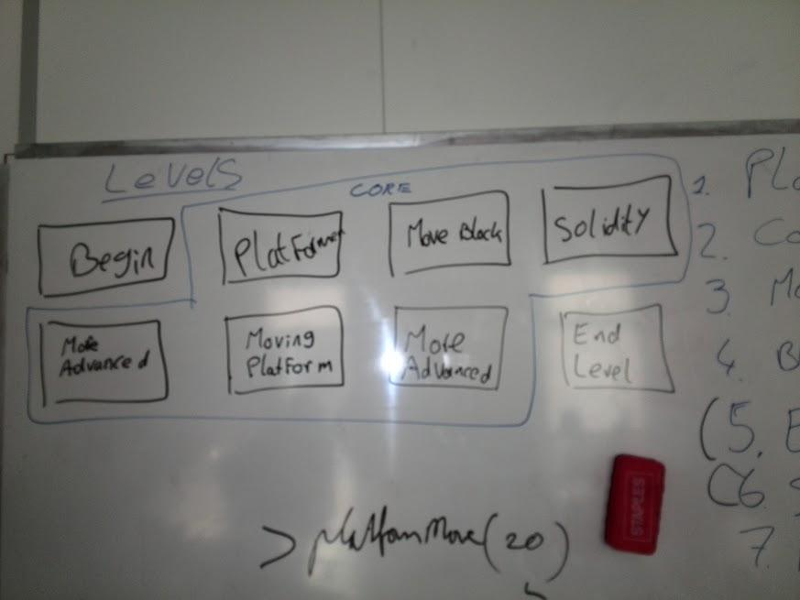

Interactive Object Selection

Left Click -> color changes (red to blue)

all blue colored objects are effected by what is written in the console.